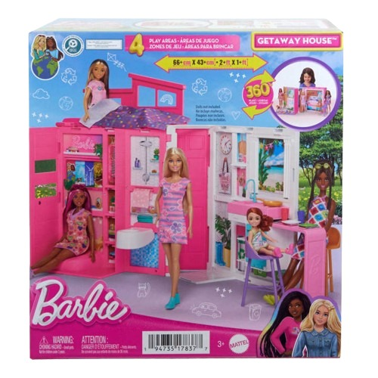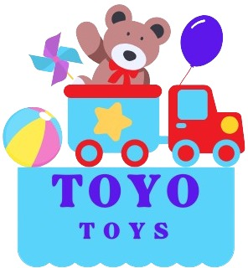

**Barbie Getaway House**

**$49.99**

**Where adventures begin!**

**Escape to a world of imagination with the Barbie Getaway House. This portable playset unfolds to reveal a two-story home complete with fun details that inspire creative storytelling**

**Product details**

**THANK YOU!**

**WELLCOME TO OUR WEBSITE**